STANDARD OPERATING PROCEDURE
SAMPLING FOR JOURNAL ENTRY TW

- Meaning:

Journal entries are crucial for accurately recording financial transactions, ensuring accountability, and facilitating financial reporting.
  - Journal Entry Sample Selection Procedure:

- Step 1:
The initial step involves finding all the journal entries (JE) from the general ledger.

Note:
The following technique is used to identify journal entries from the general ledger.
From where: Journal entries can be filtered based on various criteria such as session ID, document number, type, etc., depending upon the type of client.
How: In the column named memo/description, search for keywords such as "adjusting," " year-end adjustment," "correction," "reversal," "JE," or other similar terms.
General Journal (GJ) and Journal Voucher (JV) entries are considered to be adjusted journal entries (AJE).
- Step 2:
All the journal entries identified in the previous step are considered part of the population for extracting the journal entry sample.

Note:
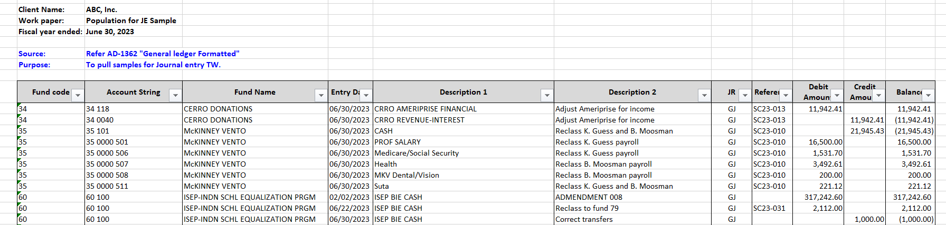
The journal entry population includes all entries related to Assets, Liabilities, Fund/Net assets balance, revenue, and expenses/expenditures.
- Step 3:
The final step is to select an adequate number of samples based on factors such as JE's number, JE's complexity, and auditor judgment.

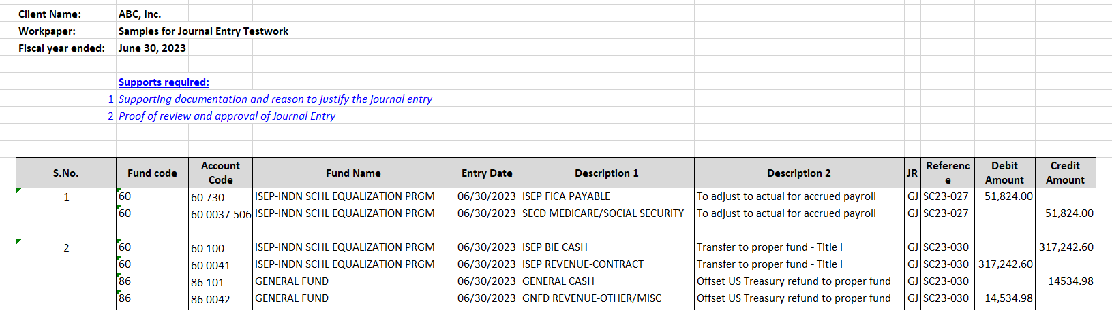
Additionally, it is essential to obtain the required supporting documentation, reasons justifying the journal entry, proof of review, and approval of the journal entry from the client. These documents should be provided along with the selected samples.

  - Perform Journal Entry Test work:

The following attributes outline specific criteria for evaluating various aspects of the journal. Here's a breakdown of each attribute:

- Is the adjusting journal entry necessary and reasonable?
Evaluate the circumstances surrounding the adjusting journal entry to determine if it is necessary and conforms to accounting principles and company policies.

- Is there supporting documentation to justify the journal entry?
Evaluate the circumstances surrounding the adjusting journal entry to determine if it is necessary and conforms to accounting principles and company policies.

- Does the amount on the supporting documentation match with the journal entry amount?
Compare the amount stated in the supporting documentation with the amount recorded in the adjusting journal entry. Ensure consistency and accuracy between the two.

- Is the journal entry related to the current fiscal year?
Compare the amount stated in the supporting documentation with the amount recorded in the adjusting journal entry. Ensure consistency and accuracy between the two.

- Is the journal entry reviewed and approved?
Compare the amount stated in the supporting documentation with the amount recorded in the adjusting journal entry. Ensure consistency and accuracy between the two.
By systematically verifying these attributes, you can ensure the accuracy, validity, and compliance of adjusting journal entries in accordance with accounting standards and organizational policies.

